1. Creating Components:

Step 1 : **src** folder er under e **components** naam e ekta folder khulte hobe,

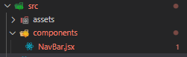

Step 2: NavBar.jsx er moddhe jsx format e code likhte hobe, for an example,

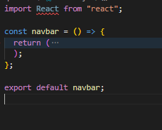

Step 3, onekta vue js er motoi use kora jay component, from **App.jsx**,  
  
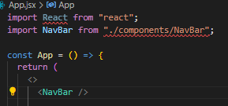

Example, ekta logo import kore just src e boshano, for an example,

Step 1: import logo from "../assets/images/logo.png";

Step 2:

<img className="h-10 w-auto" src={logo} alt="React Jobs" />